Department of Computer Science and Engineering (Data Science)
CSDS-A | Batch A5
JEPA-LLM Tuning Framework for Combating GST and Sales Tax Input Tax Credit Fraud Pattern Detection
BLOCK DIAGRAMS (ALL)
S.No. | Name of the student | Hall ticket no.
1 | B.ASHRITHA | 23K91A6732
2 | B.DIVYA | 23K91A6739
3 | A.KISHORE | 23K91A6716
4 | A.YAGNESH | 23K91A6711
Project guide: Dr. N. Ch. Ravi, Professor in CSE (Data Science)
TKR College of Engineering and Technology (Autonomous) | A.Y. 2026-27
Every diagram of the system is collected here with a caption and an explanation. The diagrams were drawn from the code (models, routes and pipeline) and each matches what the implementation does.
Section, table and figure numbers in this document follow the Final Document (17.Final Document.docx) where a section is cited; tables and figures are numbered within this document.

5.1 System Architecture
TaxSentinel is a four-tier system (Fig. 1). A React single-page application presents the screens. A FastAPI service exposes a JSON API behind a JWT bearer guard. An analytics layer in the ml/ package turns a dataset into scores, rings, chains and evidence. Persistent state is kept in SQLite (users, runs, notes), in the pickled pipeline state, in the CSV ecosystem and in the saved model weights. Gemini is the only external service.
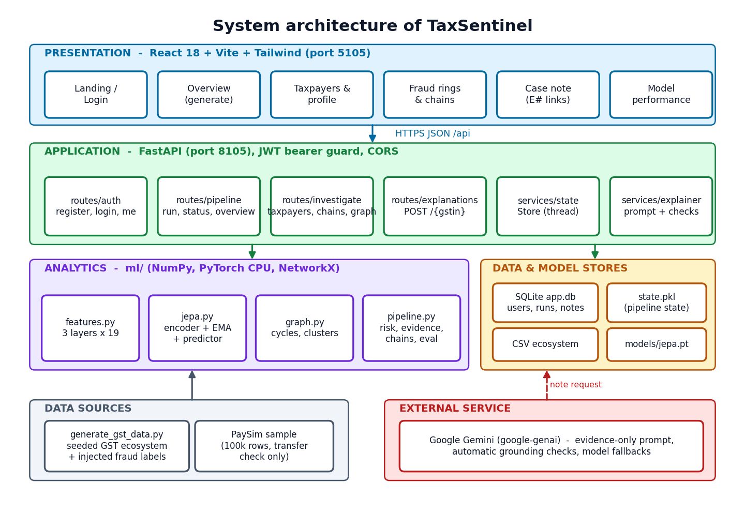
Figure 1: System architecture of TaxSentinel
Two design decisions shape the architecture. First, the analytical result is computed once per ecosystem and held in memory (and pickled to data/workspace/state.pkl), so every read endpoint is a lookup rather than a computation; this is why the read endpoints respond in milliseconds. Second, long computations never run in a request: a generation is started on a background thread and the interface polls a status endpoint, which also feeds the stage stepper and the activity log.

5.2 High-Level Workflow
The workflow in Fig. 2 has eight steps. Data are generated or loaded (1); nineteen features per taxpayer-month are computed in three layers (2); the JEPA encoder scores the deviation of each month (3); the trade graph is analysed for loops and clusters (4); every invoice is scored (5); the four layer scores are combined into a risk (6); evidence and invoice chains are built for the flagged taxpayers (7); and on request a case note is written and checked (8). Evaluation against injected labels and the rule baseline runs on the same scores.
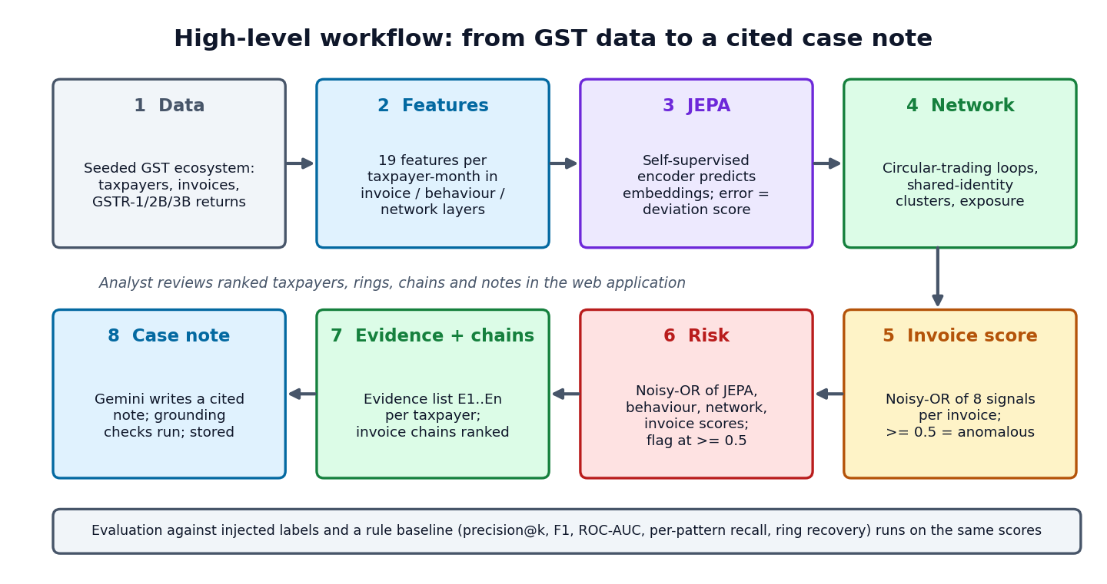
Figure 2: High-level workflow from GST data to a cited case note

5.3 Data Flow Diagrams
The context diagram (Fig. 3) shows one system, three external entities (the analyst, the Gemini API and the data generator) and the data crossing the boundary: credentials, seeds and queries in; rankings, rings, chains, notes and metrics out; evidence prompts to Gemini and cited notes back; and the generated ecosystem in.
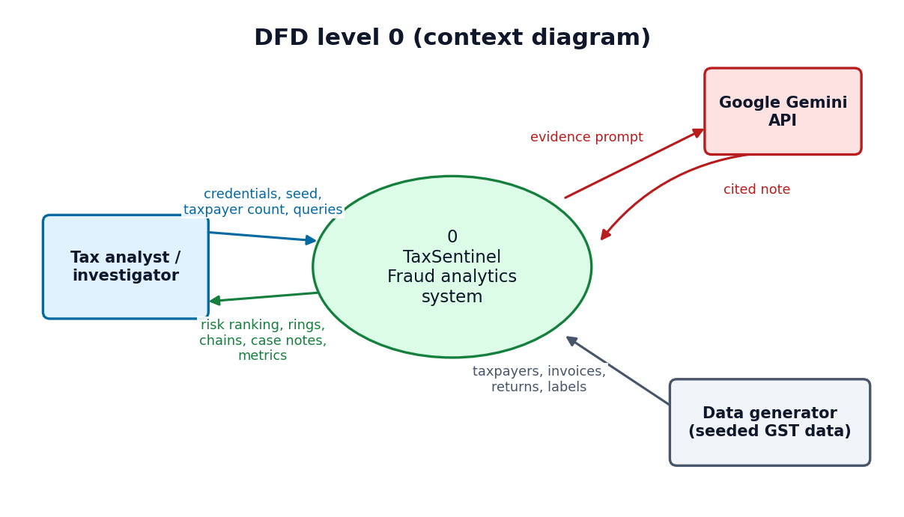
Figure 3: Data flow diagram, level 0 (context diagram)
Level 1 (Fig. 4) divides the system into five processes: authentication (1.0) against the users store; generation and analysis (2.0), which reads the CSV ecosystem and model, writes the run row and produces the pipeline state; investigation (3.0), which reads the state to serve rankings, profiles, graphs and chains; evaluation (4.0), which reads the evaluation held in the state and the training and evaluation reports; and case explanation (5.0), which reads evidence from the state, exchanges a prompt and a cited note with Gemini and stores the note and its quality checks.
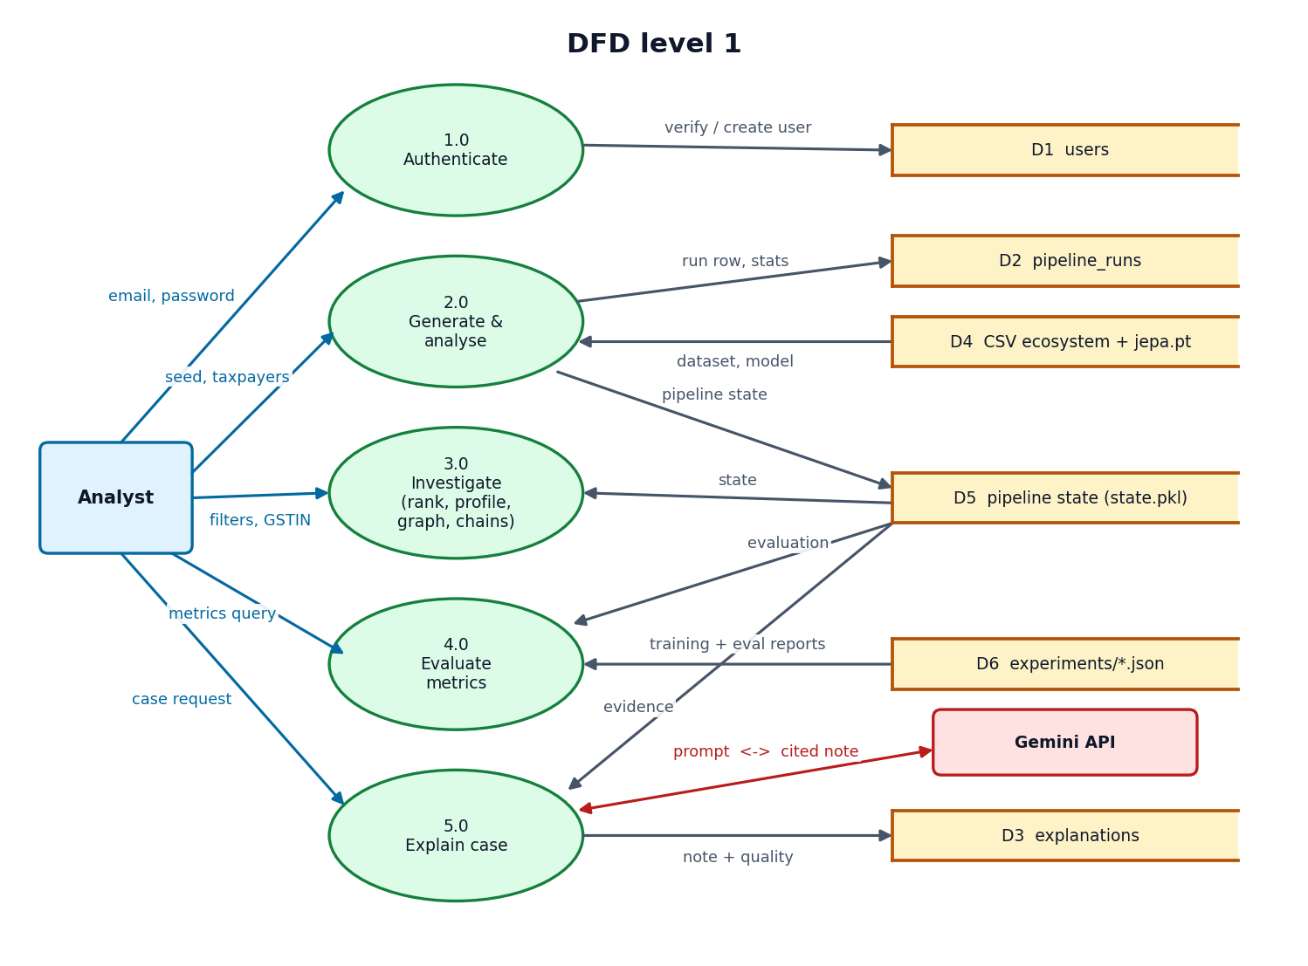
Figure 4: Data flow diagram, level 1
Level 2 (Fig. 5) expands process 2.0 into its eight internal steps. Each step reads the output of the one before it, and the network score and the JEPA and behaviour scores meet in the risk combination (2.6). The ecosystem and the model weights are read from and written to their stores, and the finished state is pickled.
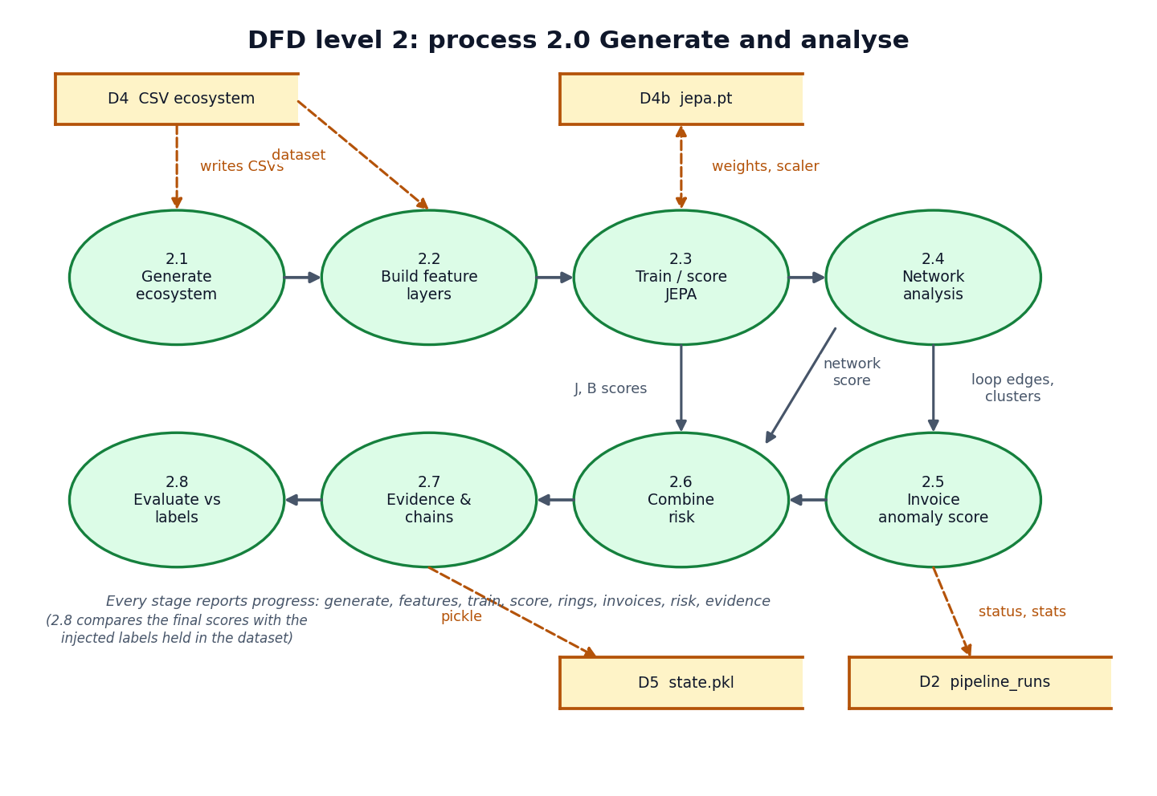
Figure 5: Data flow diagram, level 2: Generate and analyse

5.4 UML Diagrams
The class diagram (Fig. 6) shows three persistent classes (User, PipelineRun and Explanation), the Store service that holds the pipeline state and starts background runs, the pipeline and explainer modules, and the model classes JEPA, Encoder and RobustScaler. A JEPA instance owns two encoders, the online one and the exponential-moving-average target.
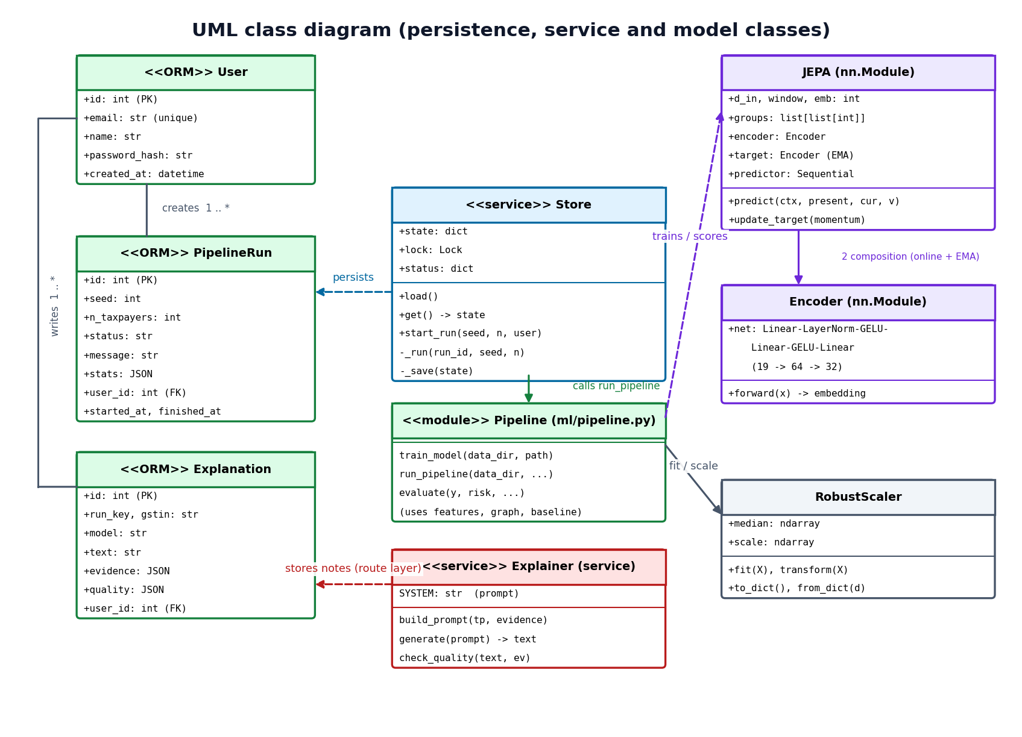
Figure 6: UML class diagram
The sequence diagram (Fig. 7) follows the main flow: sign-in, generating an ecosystem (the interface polls while a background thread runs the pipeline and updates the run row), opening the top taxpayer, and writing an explanation (the API builds the prompt from the evidence, calls Gemini, checks the grounding of the answer and saves it).
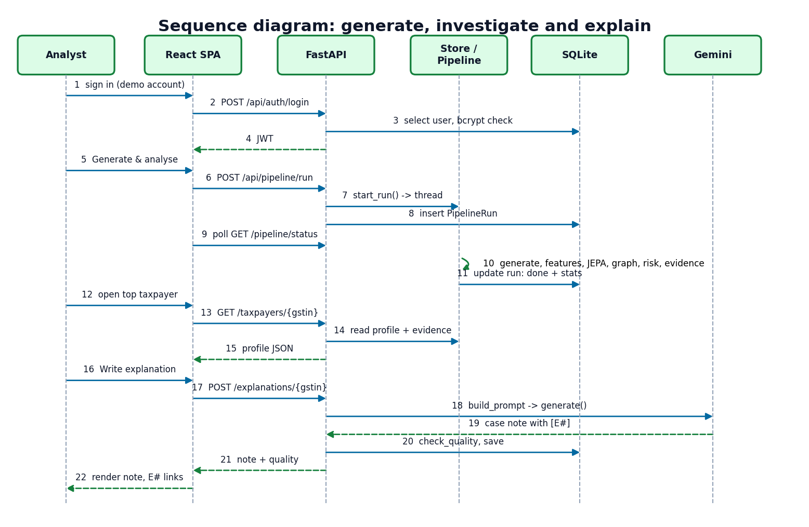
Figure 7: Sequence diagram of the main flow
The use-case diagram (Fig. 8) has the analyst as the primary actor and Gemini as a secondary actor of the case-note use case.
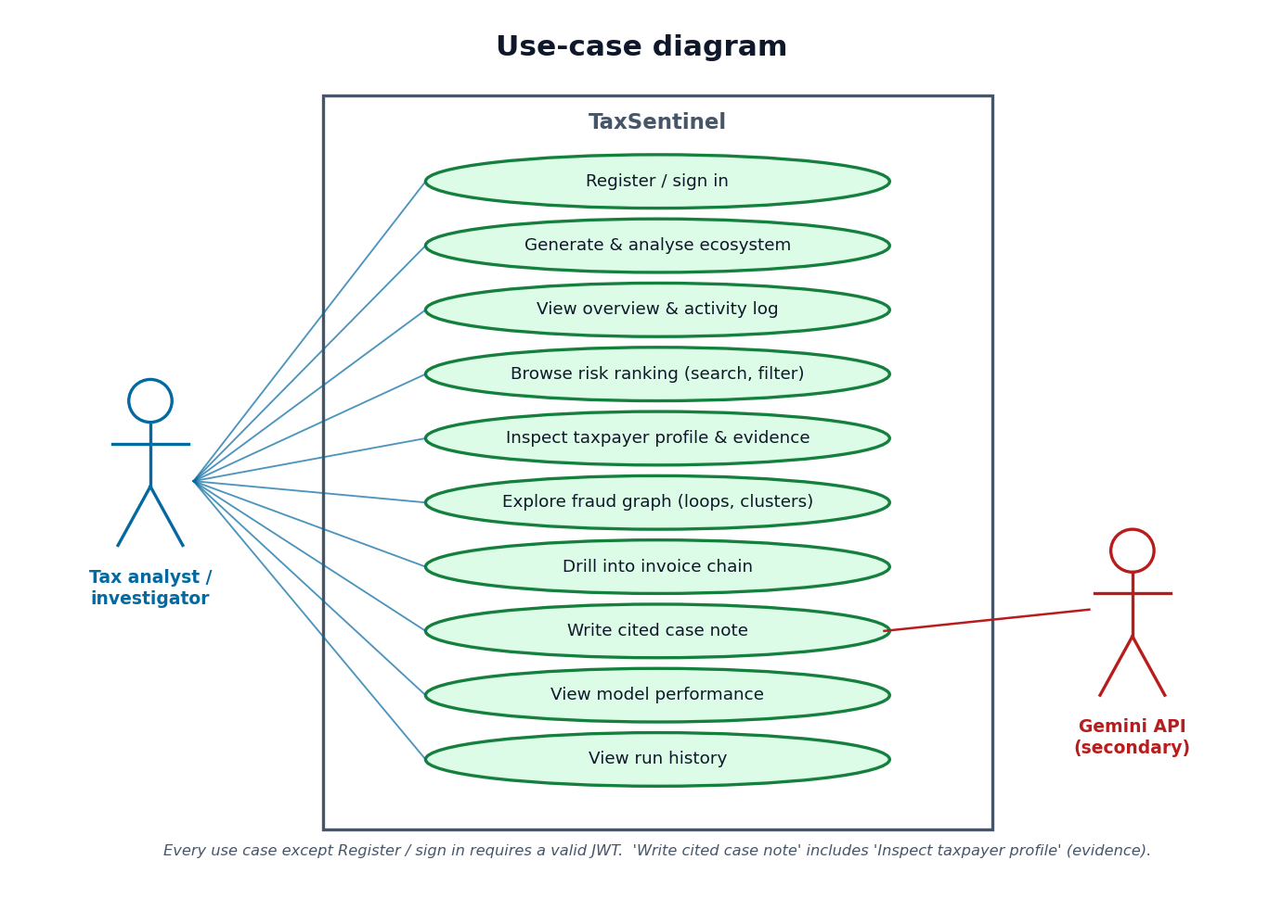
Figure 8: Use-case diagram

5.5 Database Design
Application data that changes at run time is stored in SQLite through SQLAlchemy; the analytical dataset is not, because it is read as a whole, is regenerated from a seed and is naturally columnar. Fig. 9 shows the three SQL tables and the three CSV entities that they refer to logically.
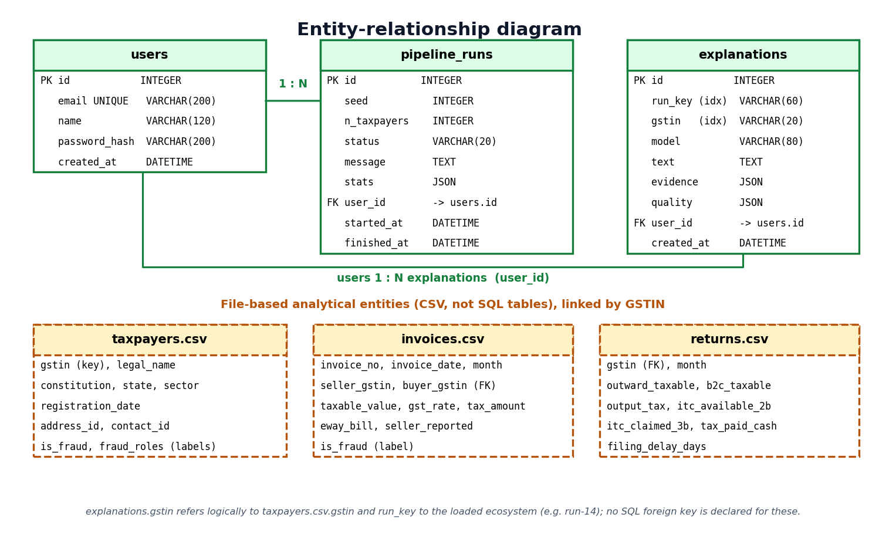
Figure 9: Entity-relationship diagram
Table 1: SQL tables
Table | Columns | Keys and notes
users | id, email, name, password_hash, created_at | PK id; email unique and indexed; password stored only as a bcrypt hash
pipeline_runs | id, seed, n_taxpayers, status, message, stats (JSON), user_id, started_at, finished_at | PK id; FK user_id to users; status is running, done or failed; stats holds the summary counts
explanations | id, run_key, gstin, model, text, evidence (JSON), quality (JSON), user_id, created_at | PK id; FK user_id to users; run_key and gstin indexed so a note is found for the loaded ecosystem; evidence is stored with the note so the citations stay valid

The CSV entities are taxpayers.csv (GSTIN, legal name, constitution, state, sector, registration date, address and contact identifiers, and the injected labels), invoices.csv (invoice number and date, seller and buyer GSTIN, taxable value, rate, tax, e-way bill flag, whether the seller reported it in GSTR-1, and the label) and returns.csv (monthly outward supplies, output tax, ITC available in GSTR-2B, ITC claimed in GSTR-3B, tax paid in cash and filing delay). The labels are carried in the files so that evaluation can run, but the model never reads them.

6.1 Overall Methodology
The methodology has seven stages that mirror the workflow in Chapter 5. (1) A seeded generator produces a GST ecosystem with injected, labelled fraud and legitimate hard negatives. (2) Three layers of features (invoice, return behaviour and network) are computed for every active taxpayer-month. (3) A JEPA encoder is trained, without labels, to predict the embedding of a month from the embeddings of the previous three months and from the month itself with one feature layer hidden; the prediction error is the deviation score. (4) The trade graph is searched for short recurring cycles and for registrations that share an address or contact number. (5) Every invoice receives a noisy-OR anomaly score from eight weighted signals. (6) The four layer scores are combined into one risk per taxpayer, taxpayers and invoice chains are ranked, and patterns and evidence are derived. (7) Gemini writes a cited case note from the evidence on request, and the result is checked. Evaluation against the injected labels and against a rule baseline is run on the same scores (Fig. 10).
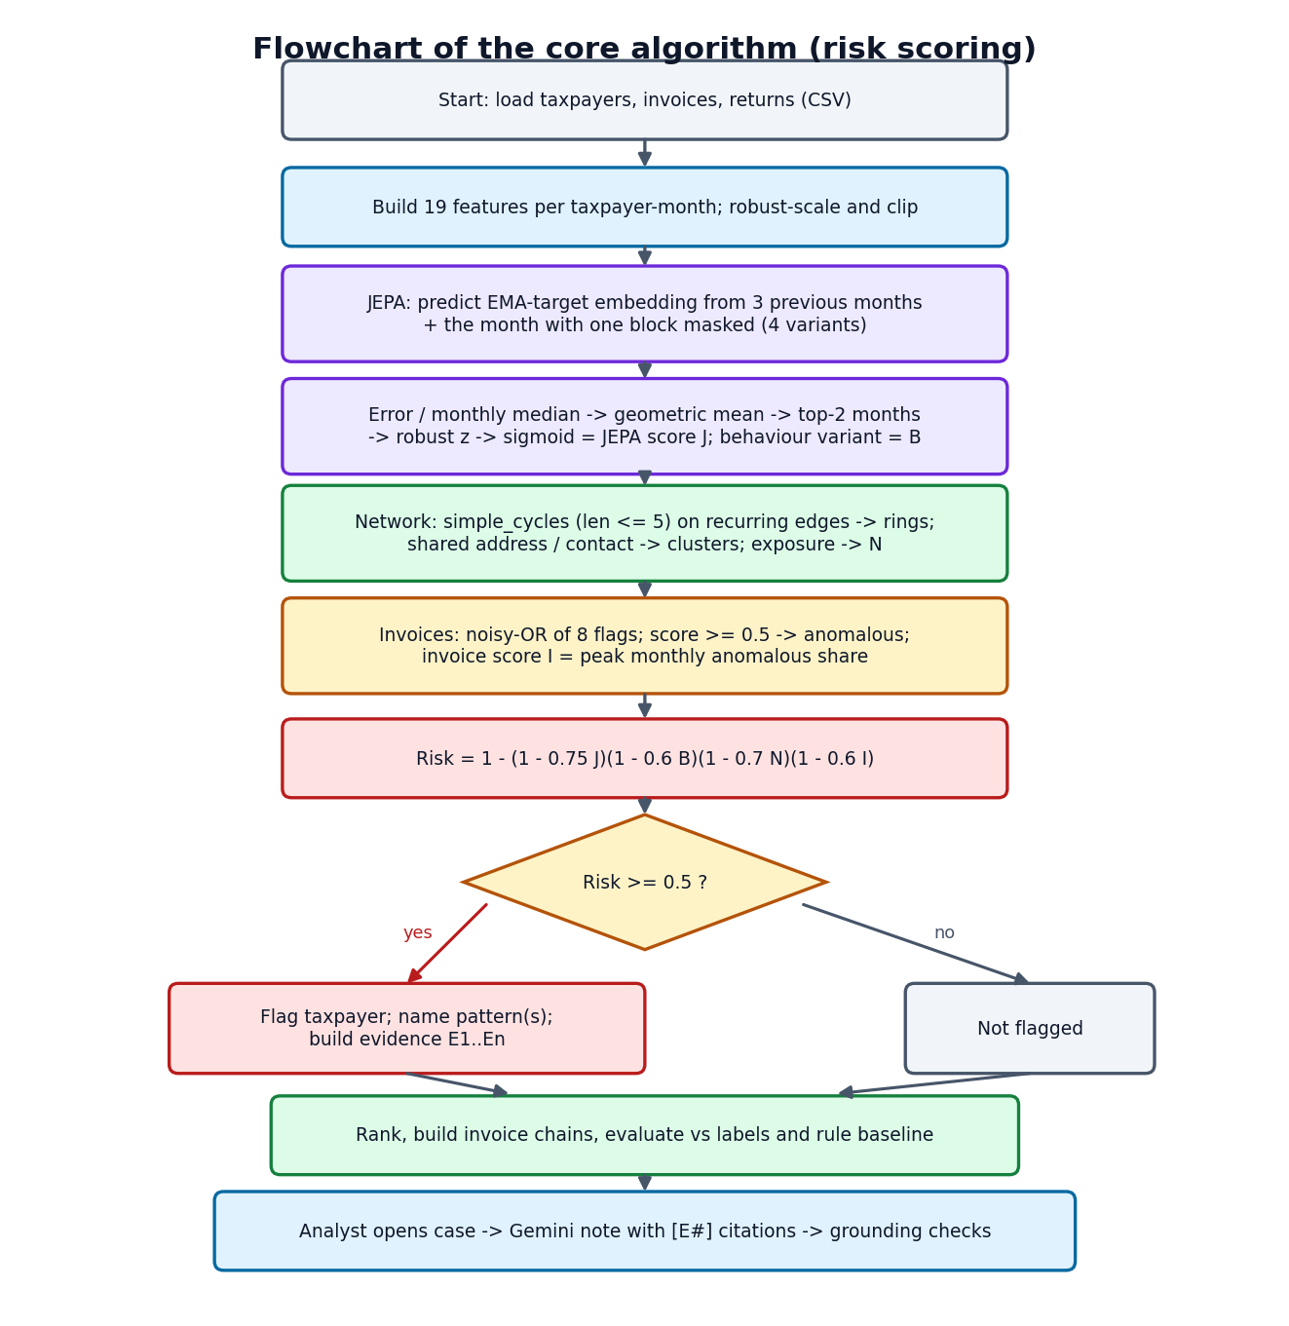
Figure 10: Flowchart of the core algorithm (risk scoring)

